****

Dr. D. Y. Patil Vidya Pratishthan Society’s

Padmashree Dr. D. Y. Patil Arts, Commerce and Science College Pimpri Pune-18.

2015-2016

A

Project Report

On

**FURNITURE SHOP MANAGEMENT SYSTEM**

Submitted in partial fulfillment of MCA(SCI) SEM IV.

as laid down by the University of Savitri Bai Phule Pune

2015-2016

Under Guidance of

**Mrs. Sonali Nemade**

Submitted By

**Rutuja Malusare**

**Shweta Mohite**



Dr. D. Y. Patil Vidya Pratishthan Society’s

Padmashree Dr. D. Y. Patil Arts, Commerce and Science College

Pimpri Pune-18.

**CERTIFICATE**

This is to certify that **Rutuja Malusare and Shweta Mohite** has successfully completed the project titled **“Furniture Shop Management System”** for MCA(SCI) sem IV of University of Savitri Bai Phule Pune for the academic year 2015-2016.

**Project Guide Vice Principal & Principal**

**Head of Department**

**(Comp.sci)**

**Examiner 1:\_\_\_\_\_\_\_\_\_\_\_\_\_\_ Examiner 2:**

ACKNOWLEDGEMENT

We are student of MCA(SCI) SEM IV are very glad to present to you this project ***“*FURNITURE SHOP MANAGEMENT SYSTEM *”*** done using JAVA with MYSQL.

The project work for “**FURNITURE SHOP MANAGEMENT SYSTEM**” has brought out for the significance of sincere effort, guidance and support that makes a project successful.

Their constant supports throughout the development of the project unable us to handle the project successfully and most completely.

We would like to thanks Head of Department

**“Dr.Ranjit Patil”** sir for his advice and support encouraged me to strive better. We would like to thanks our Project guide

**“Mrs. Sonali Nemade”** who timely made us alert of our mistakes and guided in system designing.

Last but not the least, we would like to thankful to my friends and colleagues, who have directly or indirectly, help us to complete the project.

**Your’s Sincerely**  Rutuja Malusare

Shweta Mohite

**INDEX**

|  |  |  |
| --- | --- | --- |
| Sr.no | Title | Pg.no |
| **1.** | **Introduction to Project** |  |
|  | 1. **Problem Defination** | 5 |
|  | 1. **Existing Of System** | 6 |
|  | 1. **Scope Of System** | 7 |
|  | 1. **H/W & S/W Requirement** | 7 |
| **2.** | **Proposed System** |  |
|  | 1. **Proposed System** | 8 |
|  | 1. **Objectives Of System** | 8 |
|  | 1. **User Requirement** | 9 |
|  | 1. **Fact Finding Technique** | 10 |
| **3.** | **Analysis and Design** |  |
|  | 1. **Entity Relationship Diagram** | 14 |
|  | 1. **Data Flow Diagram** | 15 |
|  | 1. **UML Diagram** | 20 |
|  | 1. **Data Dictionary** | 29 |
|  | 1. **Menu Screen & Design of Input** | 32 |
| **4.** | **Limitations & Future Enhancement** | 61 |
| **5.** | **Conclusions** | 62 |
| **6.** | **Biblography** | 63 |

1.0 **Introduction to Project**

**1.1 Problem Defination** :-

1. **No immediate retrieval of information is possible** :- The information is very difficult to retrieve and to find particular information like the stock of a specified furniture, balance, collection, as all the information is stored in the traditional data stores i.e. entry registers and we have to search it manually. This results in inconvenience and wastage of time and may be incorrect information.
2. **No immediate updation in record is possible** :- various changes to the information like employee details i.e. if any employee has changed his address or he got the higher post ,his mobile number which are required. If he wants to update the payment details of any employee, and machine updation, stock updation are difficult to make as paper work is involved.
3. **Error prone manual calculation: -** Manual calculations are error prone and take lot of time this may result in incorrect information. For example calculation of annual balance by the administrator from the bill, payment paid to the employee, manager and subtracting all the expenditure made for maintaince.

**1.2 Existing System:-**

* In the existing system all the works are done manually.
* There are two users in the existing system which does their respective tasks accordingly.

The following Paragraph describes there working i.e. How they works :-

**MANAGER**  :-

* He is one of the main user of the Existing System, whose allotment can be done newly at every year as per the rules of the management (the duration may vary) i.e. every year a new manager is selected by the admin.
* The main job manager does is he collect the details of all the employees working currently on Furniture Shop.
* Generally he stores all the employee details into one register.
* Whenever the updation of record of any employee has to be done, he searches the old record, deletes that old record and then makes the new entry into the updated record.
* As information searching is there it is the time consuming process.
* He also collects the Furniture details from the Employee and Price details from the same.
* He also asks the Employee for the final report or stock available.

**1.3 SCOPE OF THE SYSTEM**

* This system is very reliable & efficient as compared to manual system. Data can be rechecked before submitting to Database.
* It will result in fewer mistakes.
* This system provides large amount of storage of information. The necessary details of Employee, supplier, furniture Stock and etc.. are stored in database which also helps in easy retrieval of data. It will help in preparing periodic reports.

**1.4 SYSTEM REQUIREMENT**

bd15057_ **SOFTWARE REQUIREMENT :**

* **Operating System :** Platform Independent
* **Front End** **:** JAVA 1.5
* **Back End** **: MYSQL**

bd15057_ **HARDWARE REQUIREMENT :**

* **Processor** : 80x86/Pentium
* **RAM** : 32 MB (64 MB recommended)
* **Hard Disk** : 4.2 GB (20 GB recommended)
* **Keyboard** : 104 Keys
* **Monitor** : SVGA (Color)
* **Mouse**  : Logitech (Recommended**)**

###### 2.0 Proposed System

**2.1** **PROPOSED SYSTEM**

* Proposed System uses front-end as JAVA and back-end as MYSQL.
* System is User friendly.
* Less time consuming.
* Easy to maintain Records.
* No loss of Data
* Storing & Generating of reports are Easy.

**2.2 OBJECTIVES OF THE SYSTEM**

* To design and develop a system as user friendly as possible.
* To reduces clerical work.
* This not only reduces manual work but also time and storage Requirements.
* To provide the reports related to Employee, Supplier,Furniture Stock and etc..
* To improve data accuracy, integrity, consistency, retrieval of information and processing speed.
* Make a Furniture management system which will take inputs for the purchase orders and enter them to a database by validating it.
* Keeping the records of transactions like,
  + Customer’s details.
  + Customer’s registration.
  + Number of Stock available.
  + Number of orders.
  + Purchase Details.
* Unique username & password assigned to admin.
* Admin registration provides security to the system by making the system password protected.

**2.3 USER REQUIREMENT**

**Feasibility Study:**

The feasibility study involved in the conception of the project requires a study of the environment as well as the risk involved in development of the project. Proper estimation has to be carried out to ensure timely delivery of components as well as the development of cost effective solutions

**Technical Feasibility:**

Technical Feasibility is evaluated on the basis of factors like performance, ease of development, availability of hardware and reusable code availability. This system is technically feasible because different developers provide Furniture Management software. For software like Mysql and Access are available.

**Cost Feasibility:**

The costing feasibility of the project can be estimated using current estimation models such as lines of code, which allow us to estimate cost as a function of size. Thus, this also allows us to estimate and analyze the feasibility of competition of the system in the given timeframe. This allows us to have a realistic estimate as well as a continuous evaluative perspective of the progress of the project.

**2.4** **FACT FINDING TECHNIQUE**

At the time of system or before starting actual work of system, Analyst has to collect information about manual system from the user for which the system is going to be developed.

In order to collect this information, system Analyst prefers any one of the following fact finding techniques or prefer two or more fact finding techniques according to the situation. :-

**1. Interview**

**2. Questionnaire**

**3. Record View**

**4. Observation**

We followed the technique of Interview.

1. **Interview :-**

This method helped to gather most of information required for the system. We interviewed Some Manager And their working team over there, who gave us overview of system to be developed.

Following were topics covered during interviewing:-

• Information about Workers Details with Salary

• Information about Supplier Details

• Information about entered Furniture Stocks with quantity

• Information about Total sale

• Information about various types of departments available.

• Information about various registers maintained.

• Information about how the process for billing is carried out.

• Expectation

1. **Questionnaires** -:

This technique is used to collect information about various features of propose system. Questionnaire demands that we carefully consider the objective of questionnaires. And determine what will be most useful

We ask following question.

1) What are the problems in current system?

2) How much time is required to find particular match record it takes more time ?

3)Whether you get answer to your queries in short time?

4) How to maintain the customer as well as bill Information?

5) What you expect from system?

6) In Case of bill lost from member, which procedure Follow Furniture Shop?

8) Which material required to Furniture Shop for keeping records Of Customer & bills?

1. **Record Review:-**

* Sample amount of information was collected by means of register, which are maintained by the staff of the Furnitures Departments.
* The staff was very kind to provide us with sample registration forms and bill formats.
* They also showed us the registration filling formats which are currently in use.

**TECHNOLOGY IN BRIEF :**

**ABOUT JAVA : -**

* The Java programming language is robust and versatile, enabling developers to:
* Write software on one platform and run it on another.
* Its no wonder the Java platform attracts so many new developers.
* The Java programming language is a high-level language that can be characterized by all of the following buzzwords simple, distributed, architecture neutral, robust, secure, dynamic, portable, High Performance.
* The Java platform differs from most other platforms in that it's a software-only platform that runs on top of other hardware-based platforms.

**MYSQL: -**

We used MYSQL as backend for our project because of its following features.

* Error checking in forms and reports.
* View information on object dependencies.
* Back up a database or project
* Importing, exporting, and linking
* Autocorrect options and many more.

###### 3.0 Analysis And Design

* **ENTITY RELATIONSHIP DIAGRAM** 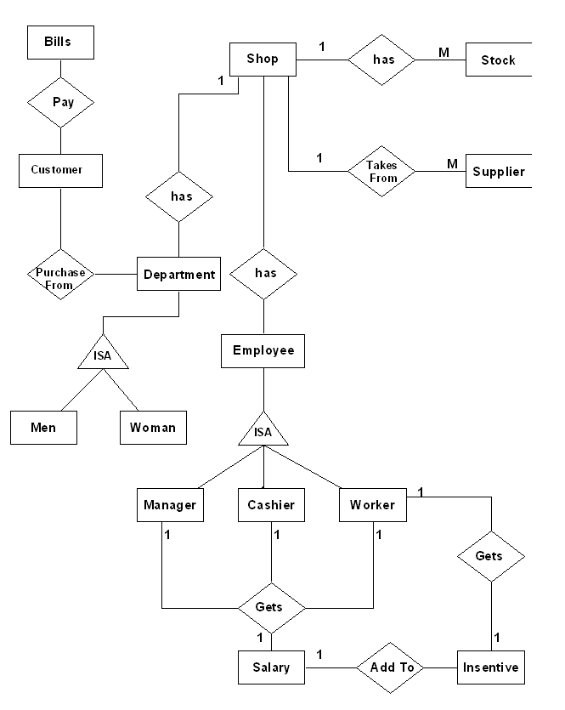

**Incentive**

**Bed Room**

**Hall**

**Kitchen**

* **DATA FLOW DIAGRAM**

**Context Level Data Flow**

**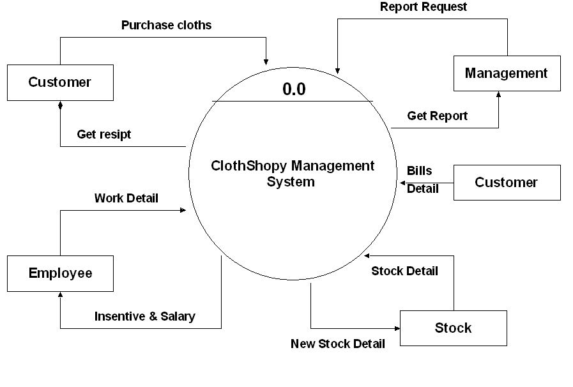**

**Get Receipt**

**Incentive & Salary**

**Incentive**

**Furniture Shop Management System**

**Purchase Furniture**

**First Level DFD**

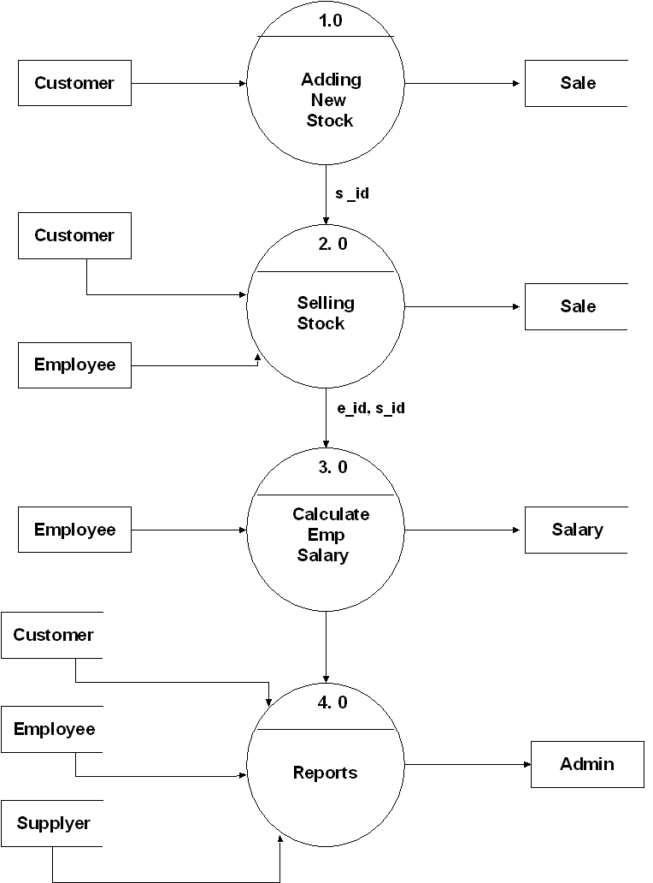

**Supplier**

**Second Level DFD**

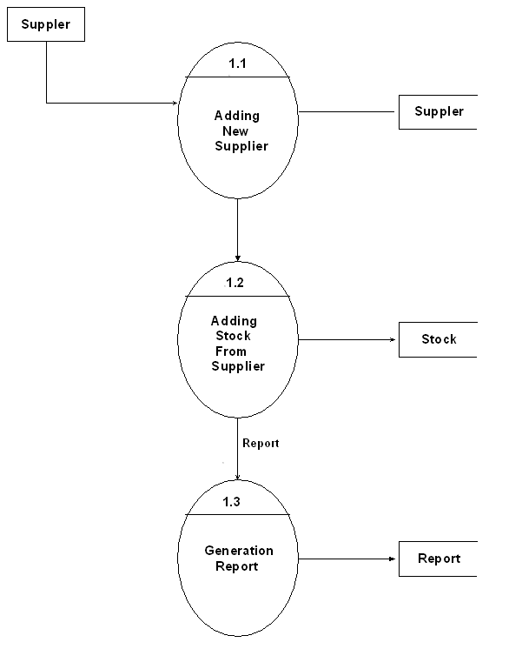

**Supplier**

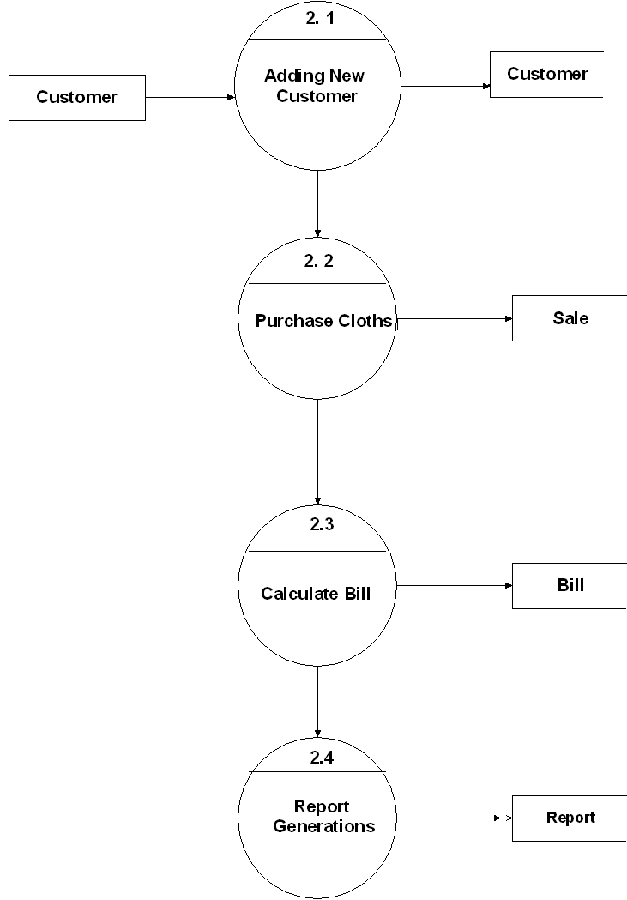

**Purchase Furniture**

Purchase Furniture

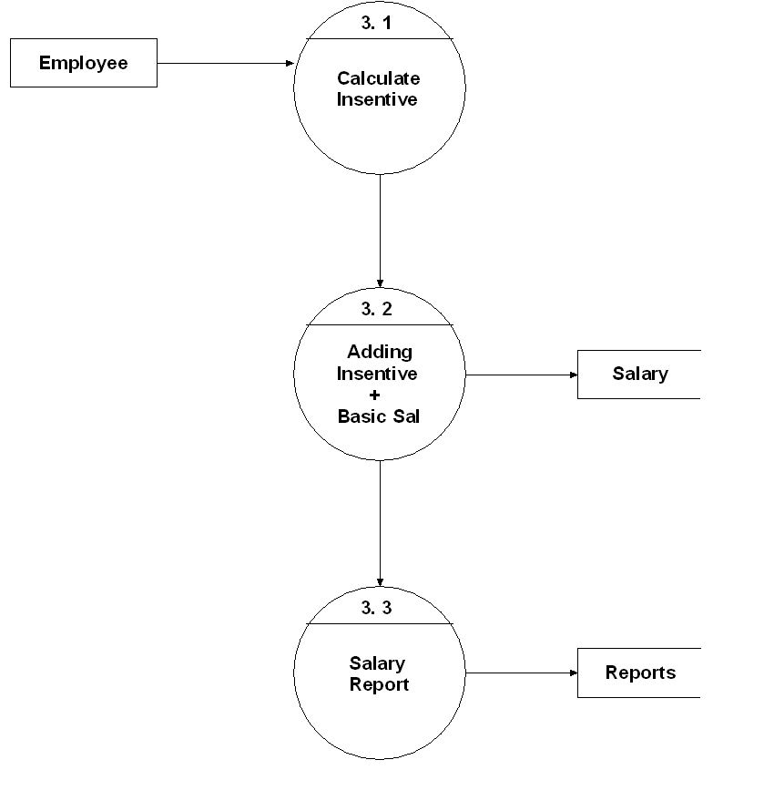

**UML Diagram**

Supplies Furniture

Furnj Zoneure Shop Mgmt System

+Start():void

+Stop():void

Salary

+Sid:int

+Eid:int

+SalDate:Date

Employee

-Empid:int

-Enm:String

-Addr:String

-PhoneNo:int

+Designation:string

-Sal:String

+AddEmp():String

+UpdateEm():string

+DeleteEmp()

Reports

-ReportTotalTrans()

-ReportTotalSupplier()

-ReportTotalStock()

-ReportMonthlyPayment()

Customer

-Custno:int

-Custnm:String

-CustPh:int

Department

+DeptId:int

+Dname:String

+AddDepart()

+UpdateDepart()

+DeleteDepart()

FurnitureStock

+FurnitureID:int

+FurnitureNm:String

+CompanyNm:String

+Type:String

+Quantity:int

+UnitPrice:int

-DeleteFurSto()

-AddFurSto()

-UpdateFurSto()

-StockPurchase()

Bill

+Billid:int

+BillDate:Date

+CName:String

+PhNo:int

+PurchaseID:int

+ToTalAmount:Float

Supplier

+SiD:int

+SNm:String

+Addr:String

+PhNo:int

+AddSup()

+UpdateSup()

+DeleteSup()

1

\*

\*

1

1

\*

Submit Report

Submit Report

\*

1

S

u

b

m

i

t

R

e

p

o

r

t

**1..\***

Monitors

\*

1

h

a

s

M

o

n

i

t

o

r

s

\*

1

S

u

b

m

i

t

a

l

l

R

e

p

o

r

t

1..\*

Pay

Name

has

1

\*

**Class Diagram**

Supplies furniture

furn:furnStock

furnNm=bed"

Supplier

SNm:"Mahalaxmi"

1

\*

\*

1

1

\*

Submit Report

Submit Report

\*

1

S

u

b

m

i

t

R

e

p

o

r

t

**1..\***

Monitors

\*

1

h

a

s

M

o

n

i

t

o

r

s

\*

S

u

b

m

i

t

a

l

l

R

e

p

o

r

t

1..\*

Name

has

1

\*

b:Bill

Billid="1109"

c:Customer

Cnm="ravi"

cl:furn Shop Mgmt System

<<control>>

1

s:Salary

\*

r :Report

d:Department

Dnm="Bed room"

e:Employee

EmpNm="ash"

Pay

**Object Diagram**

Purchase

furniture

Update

Balance

Gives

Payment

Cash

Card

Create & Accept

Payment

Prepare Statement

Maintain

System

Generates

Alert

Add / Modify / Delete

Informatiom

Employee

Detailes

Save Transaction

Administrator

Furniture DB

Customer

Clerk

**Use Case Diagram**

<extends>

<extends>

<extends>



:Furniture Shop



:Billing clerk



:Administrator

Select items

Select/deselect

item

verify amount

Prepare Bill

Customer

Issuebill details

Payment /

update card

Receipt

item list

bill details

accept payment

gives receipt

Statement

+ sign Receipt

makes

payment / Register

**Sequence Diagram**

Make

Statement



Furniture

Mangement

System



e : Employee



d : Department



s : Supplier



sal:Salary

1)

Add

2)

Delete

3) Update

Administrator

Salary Information

1

.

1

1

.

2

1

.

3

1

.

4

**Collaboration Diagram**

M:FurnShopMember



c : Customer



b:Bill

C:Customer

Purchase(Furniture)

2

: Purchase

2

:

1

Generate Bill

1

: Ok To Purchase

Customer

Cashier



Select Furniture

for purchase



Wait in check-out

queue



Prepare bill

for customer



Make Payment



Prepare for

next

Customer



Verify amount



Verify

Signature

[by Cash]

[by Card]

**Activity Diagram**



Login

System



Delete

Do/delete Employee

Do/delete FurnStock

Do/delete Department

Do/delete Supplier



Add

Do/add Employee

Do/add FurnStock

Do/add Department

Do/add Supplier



Update

Do/update Employee

Do/update FurnStock

Do/update Department

Do/update Supplier



Reports

Do/show Supplier List

Do/show FurnStock List

Do/show Customer Transaction

Do/show Monthly Payments



Transaction

bid = Bill Id

sal = Salary

Do/Generate Bill

Do/Pay Salary



Help

Entry/About Us

Entry/Credit



Exit



Final State

[Check Out]



Login

Failed

[Reenter Password]

[Password Incorrect]

[Menu of Systems]

[Login]

**Statechart Diagram**



Furn Mangement System

<<Application>>



Employee



Administrator

<<Monitors>>



Customer



Reports



Supplier



A

c

c

e

s

s

R

e

p

o

r

t

s



Furn DB

<<Database>>

Stores Reports

JDBC

**Component Diagram**

Data acess employee

Supply Order

Cust Details



Billing

Application.exe



Reports.exe



MYSQL



Components

Components

Components

**Listing**

<<Storage>>

Multiple Listings

TCP / IP

Database Server

JDBC

Connection

Furniture Shop Server

IListing

**Deployment Diagram**

**Data Dictionary** :-

**Employee**

|  |  |  |  |
| --- | --- | --- | --- |
| **FIELD NAME** | **DATA TYPE** | **DESCRIPTION** | **KEYS** |
| EmpId | Text | Employee I d | PK |
| EmpName | Text | Employee Name |  |
| Address | Text | Employee Address |  |
| PhoneNo | Text | Employee Phone number |  |
| Designation | Text | Employee Designation |  |
| DepartmentID | Text | Employee Department Id | FK |
| Salary | Number | Employee Salary |  |
| Password | Text | Employee Password |  |
| MDate | Date/Time | Employee Join date |  |

**FurnitureStock**

|  |  |  |  |
| --- | --- | --- | --- |
| **FIELD NAME** | **DATA TYPE** | **DESCRIPTION** | **KEYS** |
| FurnitureID | Text | Furniture Id | PK |
| FurnitureName | Text | Furniture Name |  |
| CompanyName | Text | Furniture Company Mark |  |
| Description | Text | Furniture Description |  |
| Type | Text | Furniture Type |  |
| Quantity | Number | Furniture total Quantity |  |
| UnitPrice | Number | Furniture per Unit Price |  |

**Department**

|  |  |  |  |
| --- | --- | --- | --- |
| **FIELD NAME** | **DATA TYPE** | **DESCRIPTION** | **KEYS** |
| DeprtmentID | Text | Department I D | PK |
| DName | Text | Department Name |  |

**Supplier**

|  |  |  |  |
| --- | --- | --- | --- |
| **FIELD NAME** | **DATA TYPE** | **DESCRIPTION** | **KEYS** |
| SupplierID | Text | Supplier I D | PK |
| SuppName | Text | Supplier Name |  |
| Address | Text | Supplier Address |  |
| PhoneNo | Text | Supplier Phone Number |  |

**StockPurchase**

|  |  |  |  |
| --- | --- | --- | --- |
| **FIELD NAME** | **DATA TYPE** | **DESCRIPTION** | **KEYS** |
| StockPurchaseID | Text | Stock Purchase ID | PK |
| FurnitureID | Text | Furniture Id | FK |
| SupplierID | Text | Supplier I D | FK |
| PDate | Date/Time | Purchase Date |  |

**Salary**

|  |  |  |  |
| --- | --- | --- | --- |
| **FIELD NAME** | **DATA TYPE** | **DESCRIPTION** | **KEYS** |
| SalID | Text | Salary Id | PK |
| EmployeeID | Text | Employee I d | FK |
| Incentive | Number | Employee Incentive |  |
| Salary | Number | Employee Salary |  |
| NetSalary | Number | Employee Net Salary |  |
| SalDate | Date/Time | Salary Payment Date |  |

**Bill**

|  |  |  |  |
| --- | --- | --- | --- |
| **FIELD NAME** | **DATA TYPE** | **DESCRIPTION** | **KEYS** |
| BillID | Text | Bill Number | PK |
| BillDate | Date/Time | Billing Date |  |
| CustomerName | Text | Customer Name |  |
| PhoneNo | Text | Customer Phone Number |  |
| PurchaseID | Text | Purchase ID | FK |
| Total Amount | Number | Total Amount |  |
| EmployeeID | Text | Employee ID (whose sale) | FK |

**Purchase**

|  |  |  |  |
| --- | --- | --- | --- |
| **FIELD NAME** | **DATA TYPE** | **DESCRIPTION** | **KEYS** |
| PurchaseID | Text | Bill Number | PK |
| FurnitureID | Text | Furniture Id | FK |
| Qty | Number | Total Number Of Quantity |  |

**~ Menu Screens ~**

**1.Welcome Screen**

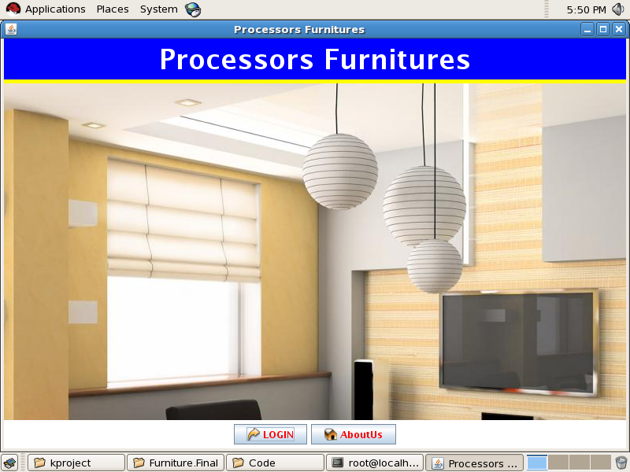

**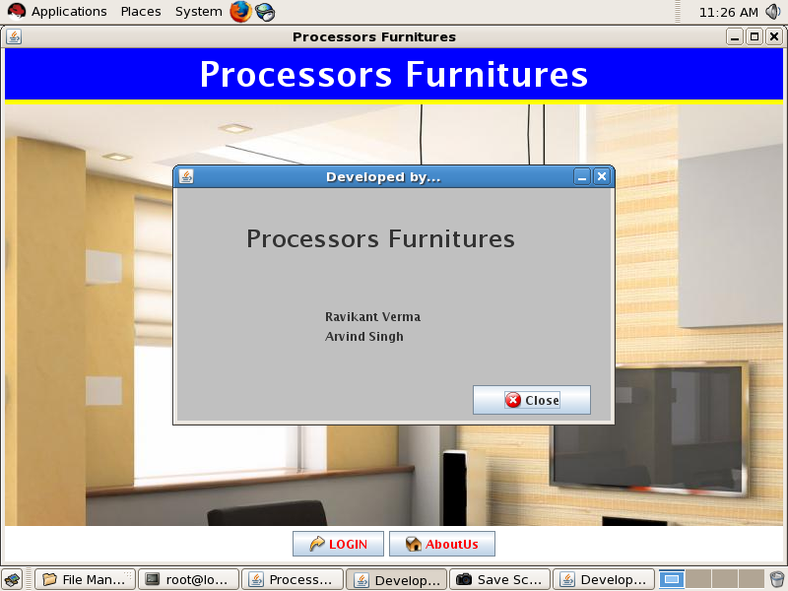**

**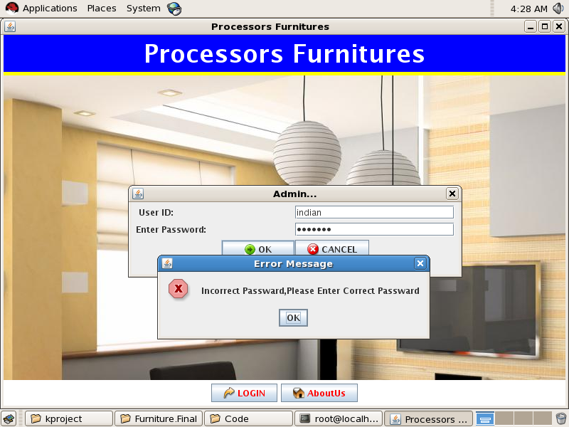**

**3.Login Admin**

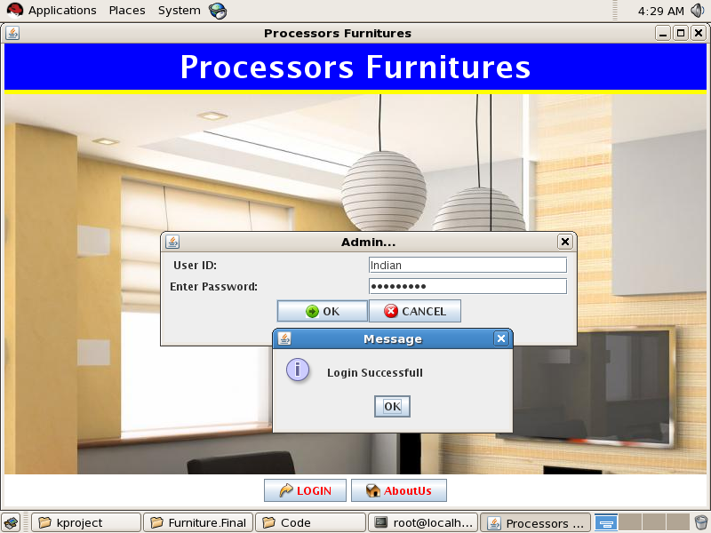

**4.Admin Screen**

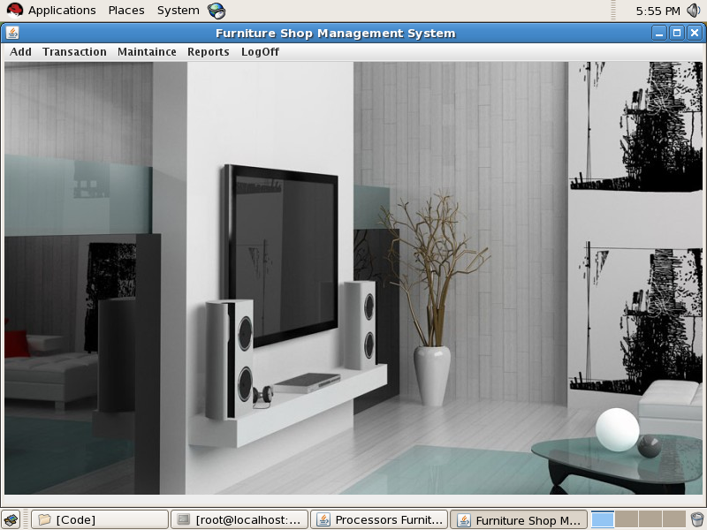

**5.Add Department**

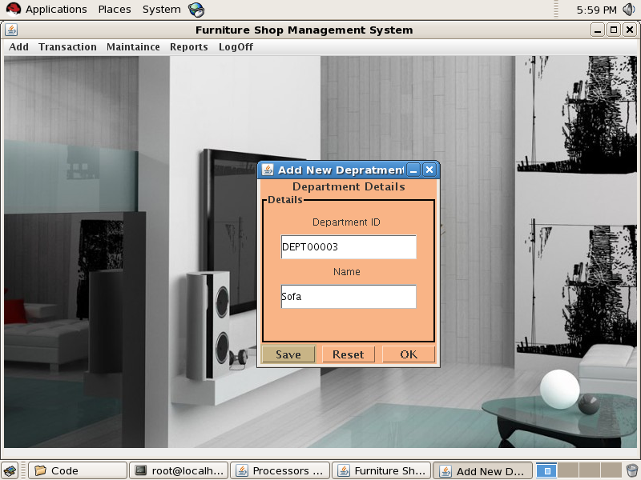

**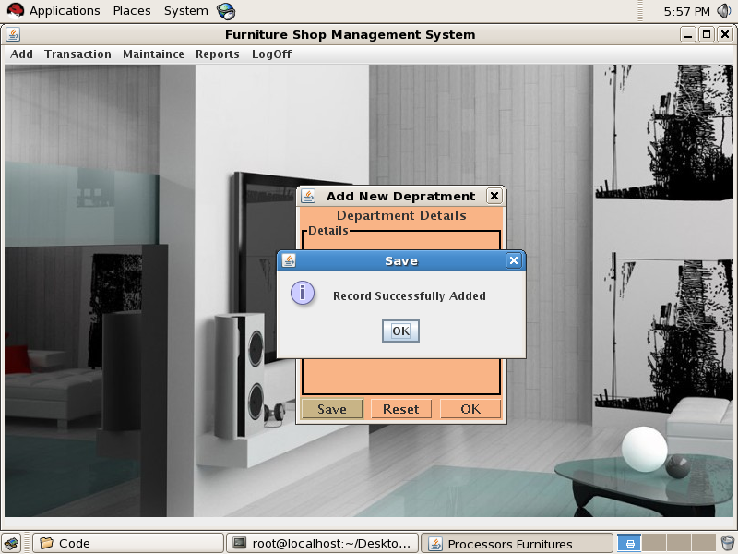**

**5.1 Department Report**

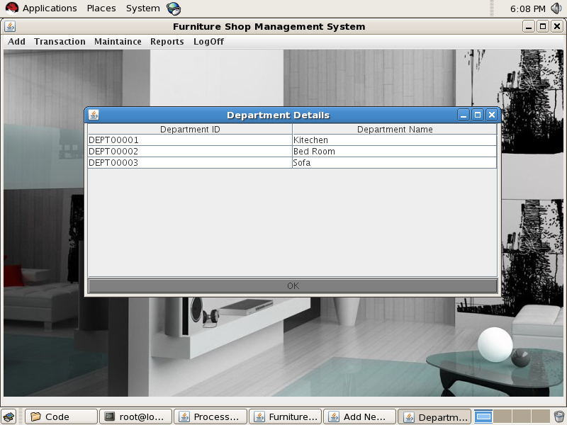

**5.2 Update Department**

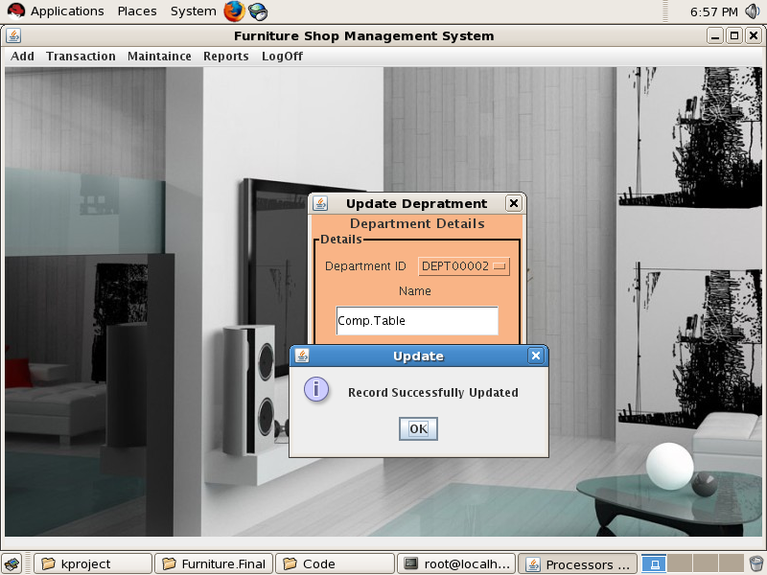

**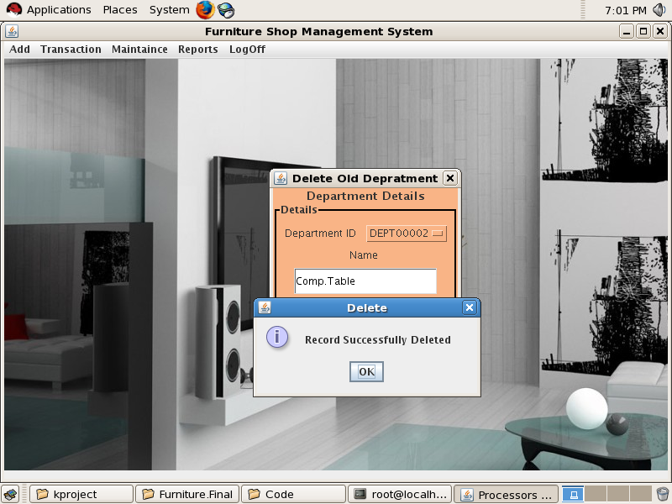**

**6 Employee Details**

**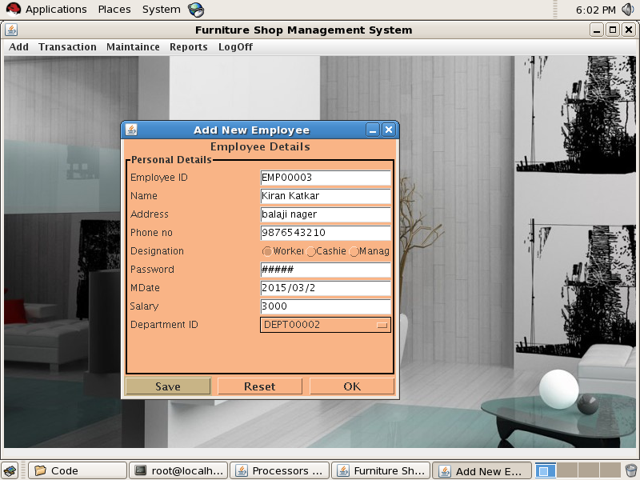**

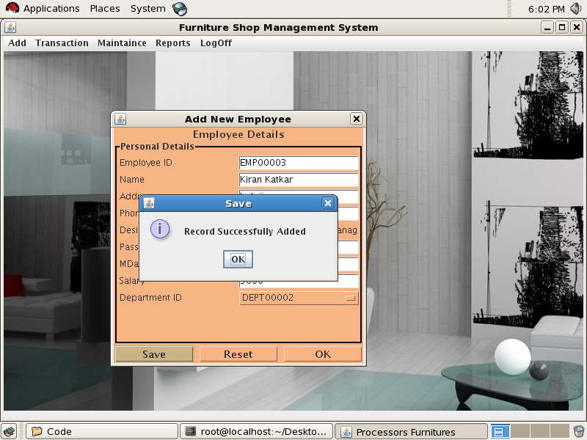

**6.1 Update Employee**

**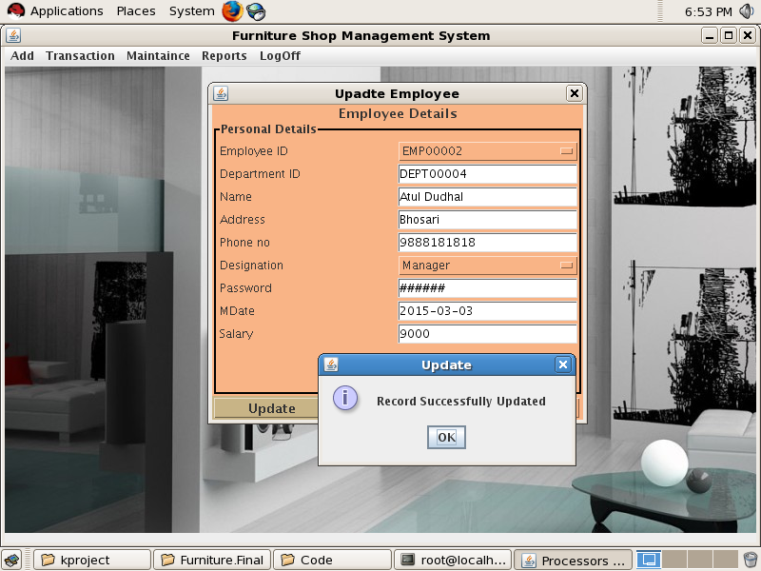**

**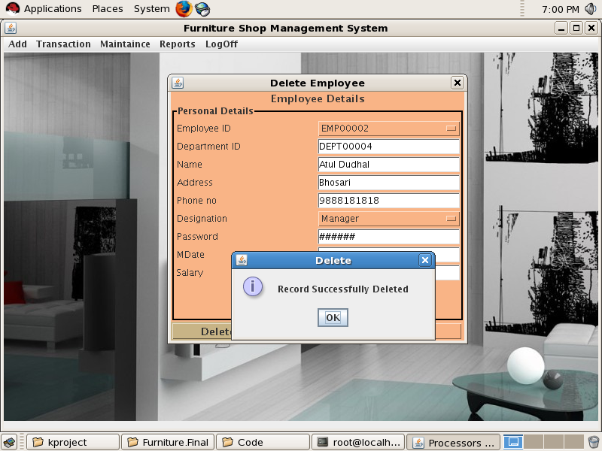**

**7 .Stock Detaile**

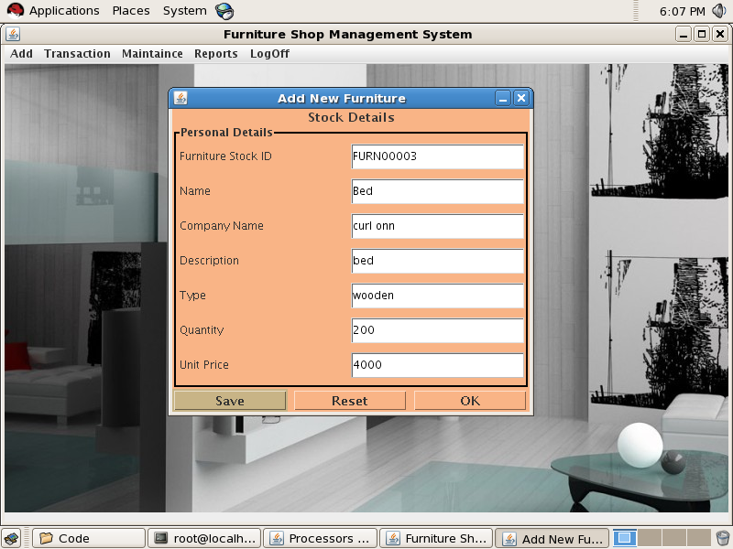

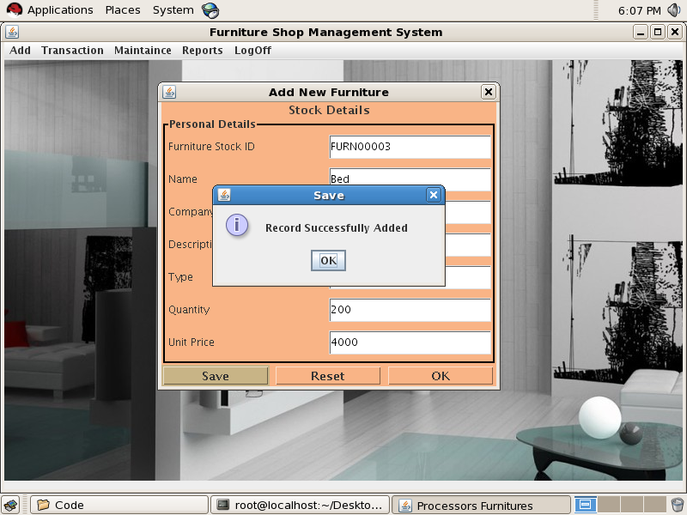

**7.1 Stock\_Report**

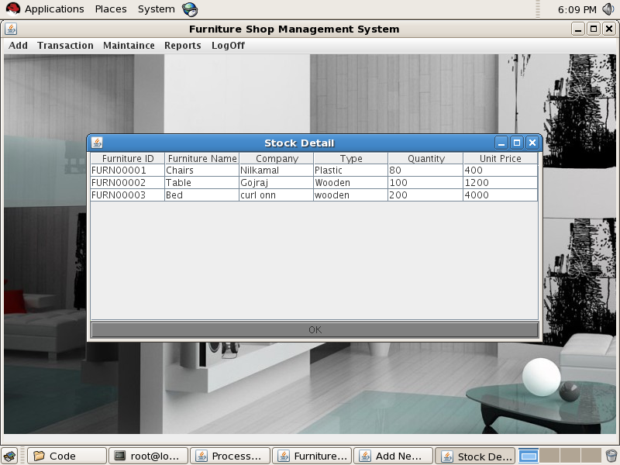

**7.2 Update Stock**

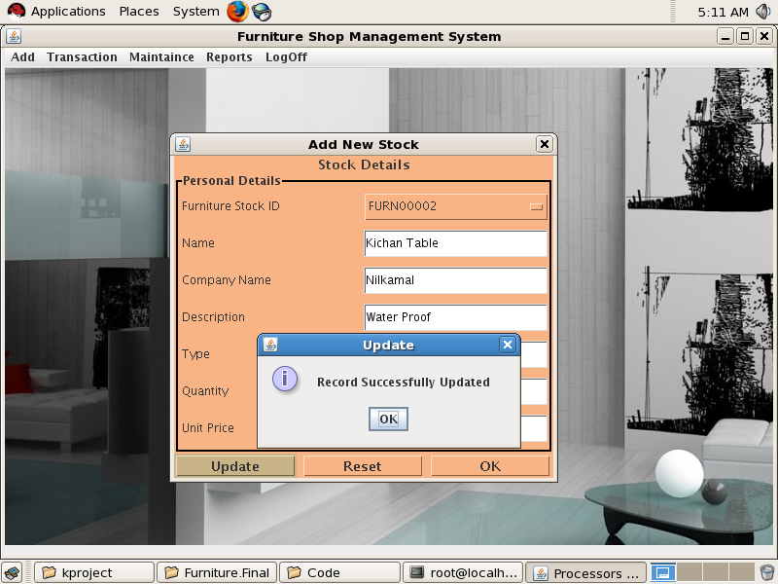

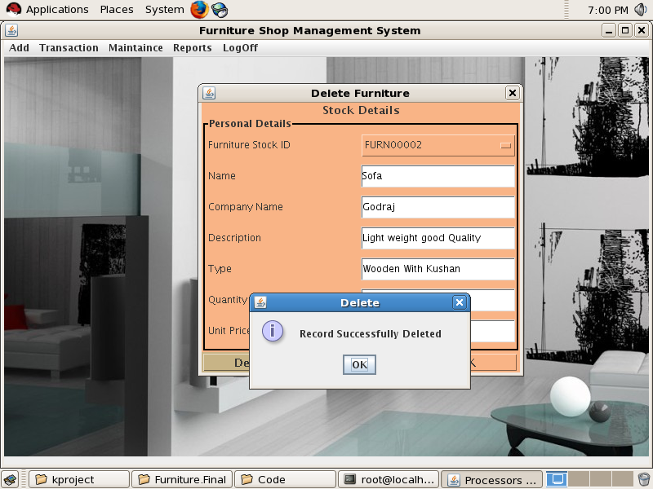

**8. Supplier Detailes**

**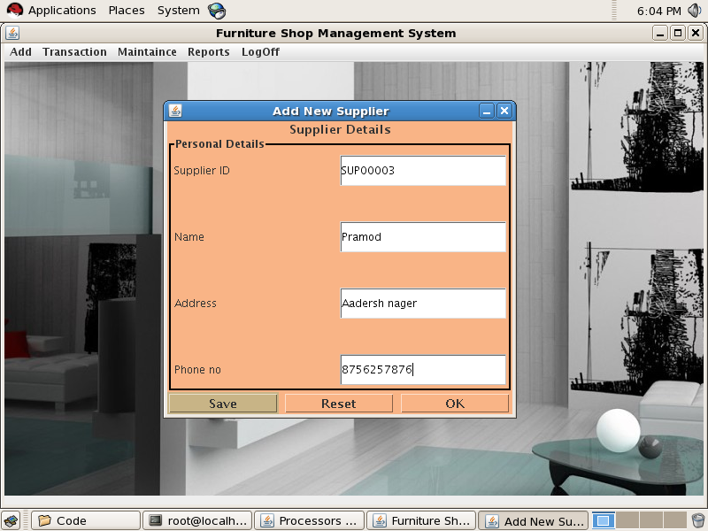**

**8.1 Add Supplier**

**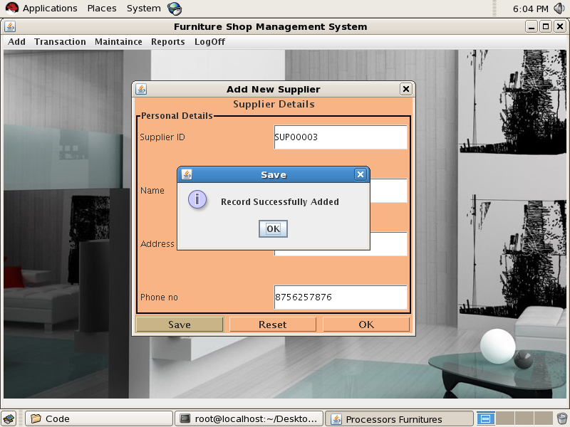**

**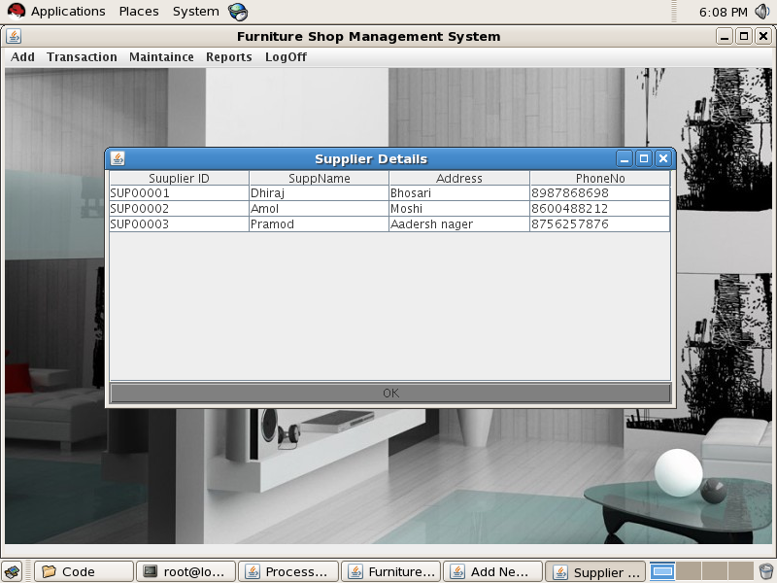**

**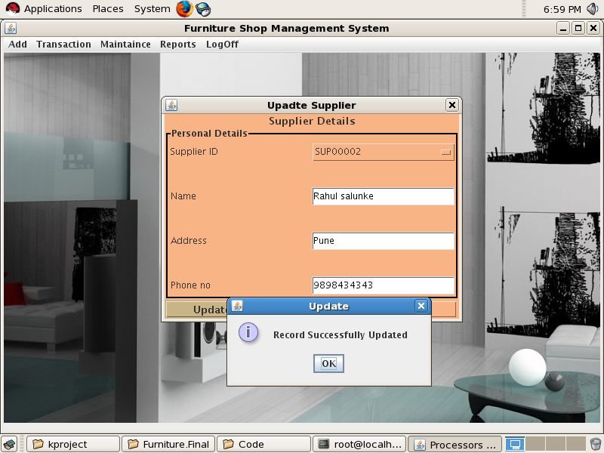**

**9 Generate Bill**

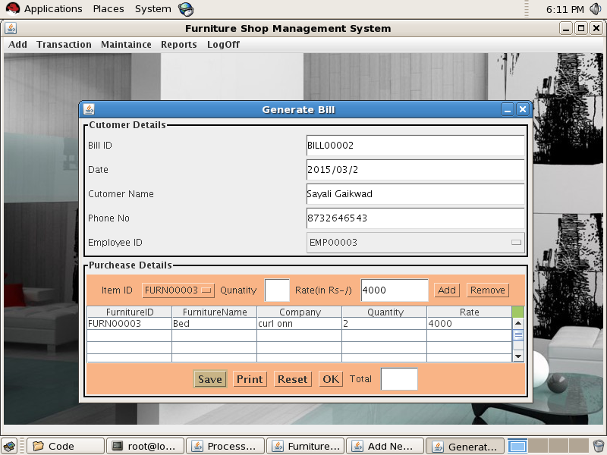

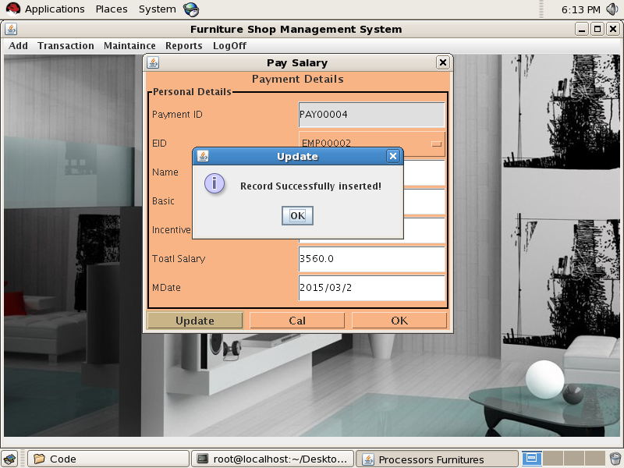

**9.1 Employee Payment**

****

**10 Monthaly Payment**

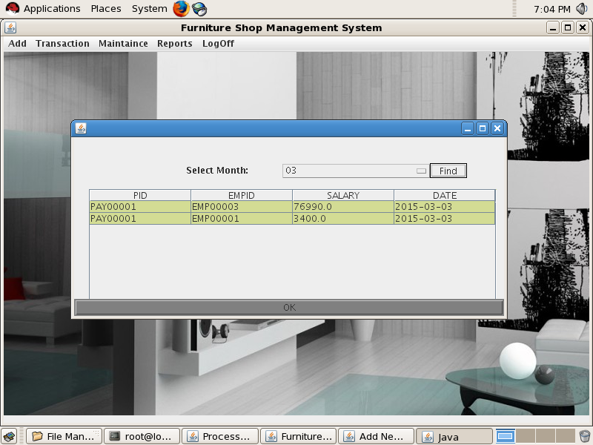

**User Manual**

1. *Login with given login id and password. If incorrect entry is*

*made then not*

1. *After login menu, screen will be pop-up with various Modules like customer details, product details, supplier details, employee details, system details.*
2. *Select appropriate option from the above go through product, customer, supplier, employee respective updation ,deletion ,insertion through administration.*
3. *Click on System details to view its details of record of stock, daily reports.*
4. *Click on customer details to fill customer form and updation of customer.*
5. *Click on product details to update new product details and view the information of product.*
6. *Click on employee details to add new employee information ,attendance of employee , and deletion, updation of employee with his/her payment.*
7. *Click on supplier details to add supplier information like how much product to be order in what date?, and how about the payment status etc.. and also perform updation of supplier.*

**LIMITATIONS**

-Booking of advance order is not done.

-Only one customer can login at time.

-Only one type of item can be ordered at time.

**Future Enhancement**

* We don’t have back up like print receipt, in Future we are looking for it.
* We don’t have provide any search facility for Furniture or any department, so we are looking for it.
* We don’t have Separate Log in for employee so we will be try to do it near future.
* This Application is standalone in future it will be connected to network for Centralization of users Information.
* In Feature this System also provides barcode Facility along with online information & Processing data.
* Booking of advance order is done.
* Many customer can login at time.
* Many type of item can be ordered at time.

**CONCLUSION**

**Proposed System is** :-

* **User Friendly** :

The System has got much Simplified screen which makes the system fast enhances quick and Accurate data.

* **Validations Check :**

The System has various Validation Checks and it also gives appropriate error message and Provides the necessary help.

* **Report Generation :**

The System can generate various reports giving employee details, working details, deleted details etc.

* **Easy to Learn :**

The System is easy to understand, this is mainly due to simple functionality. Even a Layman can be trained to use this system.

* Working on this project was a good experience. We understood the Importance of planning and designing phase of the Software Development.
* The Furniture Shop System has been tested for various options & the results are found to be Satisfactorily.
* Developing the project has helped us to gain some experience on real time development procedure.
* The Furniture Shop System has been tested for various options & the results are found to be Satisfactorily.
* This System is developed using JAVA project is implemented on Independent Platform.

**BIBLOGRAPHY**

* **Java 6 Complete Reference**

- By Herbert Schiltdt .

* **Java 6 Black Book**

-By Kogent Solutions. Dreamtech Press.

**Websites :-**

Java.sun.com